Environment Variable

1. How can you know what is the secondary command prompt set your system ?
How can you change the secondary command prompt from the default to your username ?
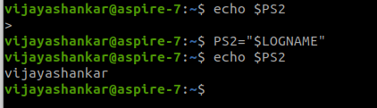

2. How can you ensure that the mv command (used for renaming a file) always asks for permission before overwriting an existing destination file ?
[ Hint : use alias command ]
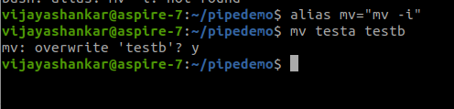

Basics Of System Administration in Linux

1) Create a new user account and home directory called "Duck"
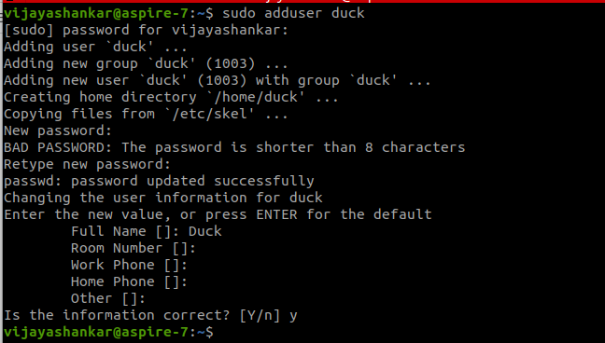
2) Set the user account "Duck's" expirey date as 07 - 01 - 2015

3) find the id of the user account "Duck"

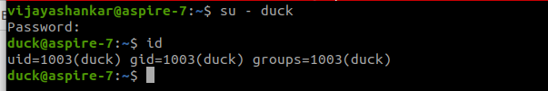
4) Type df and du commands and see the output on your terminal.

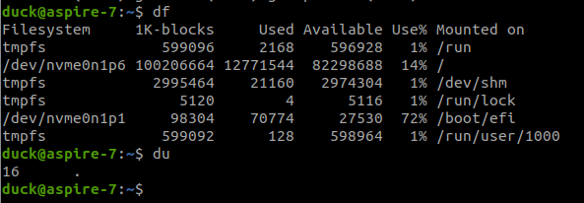
5) Type this command on the terminal and see the output :
du -ch *.txt
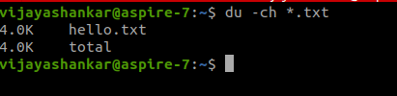

6) Delete the user account "Duck" permanently along with its home folder.
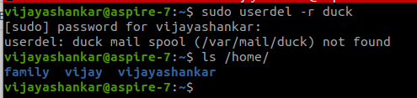
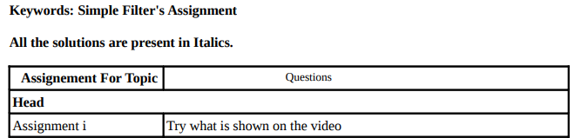

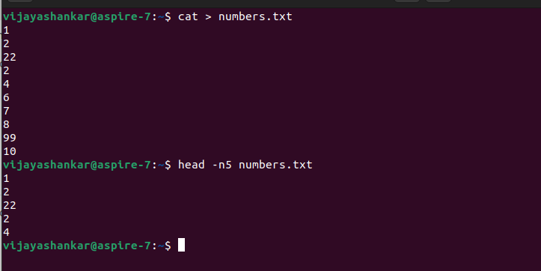

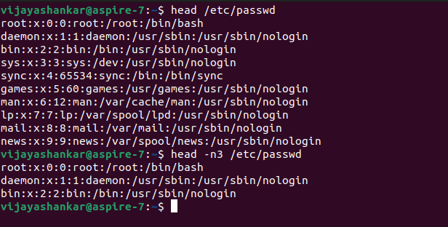

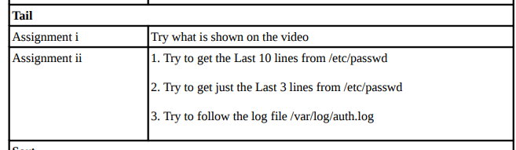
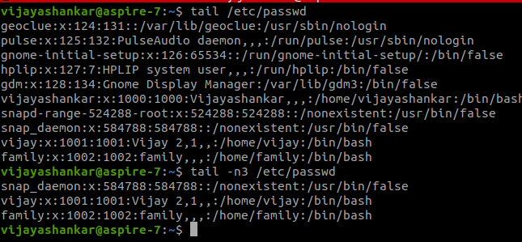
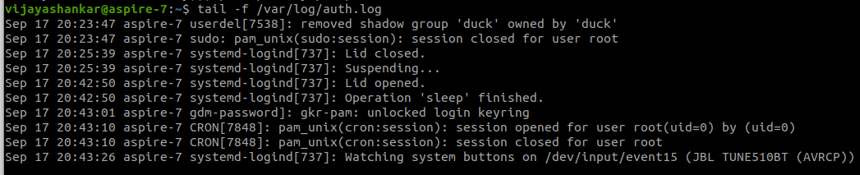

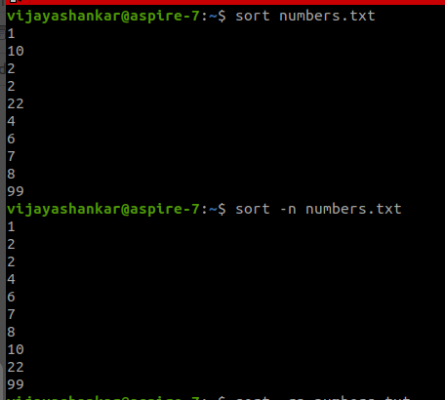
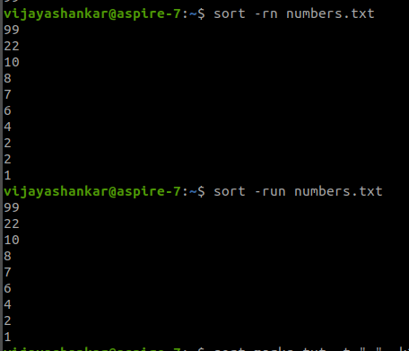

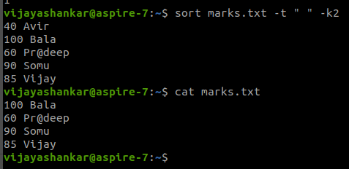

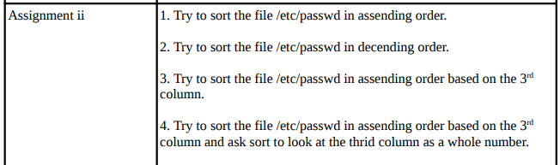
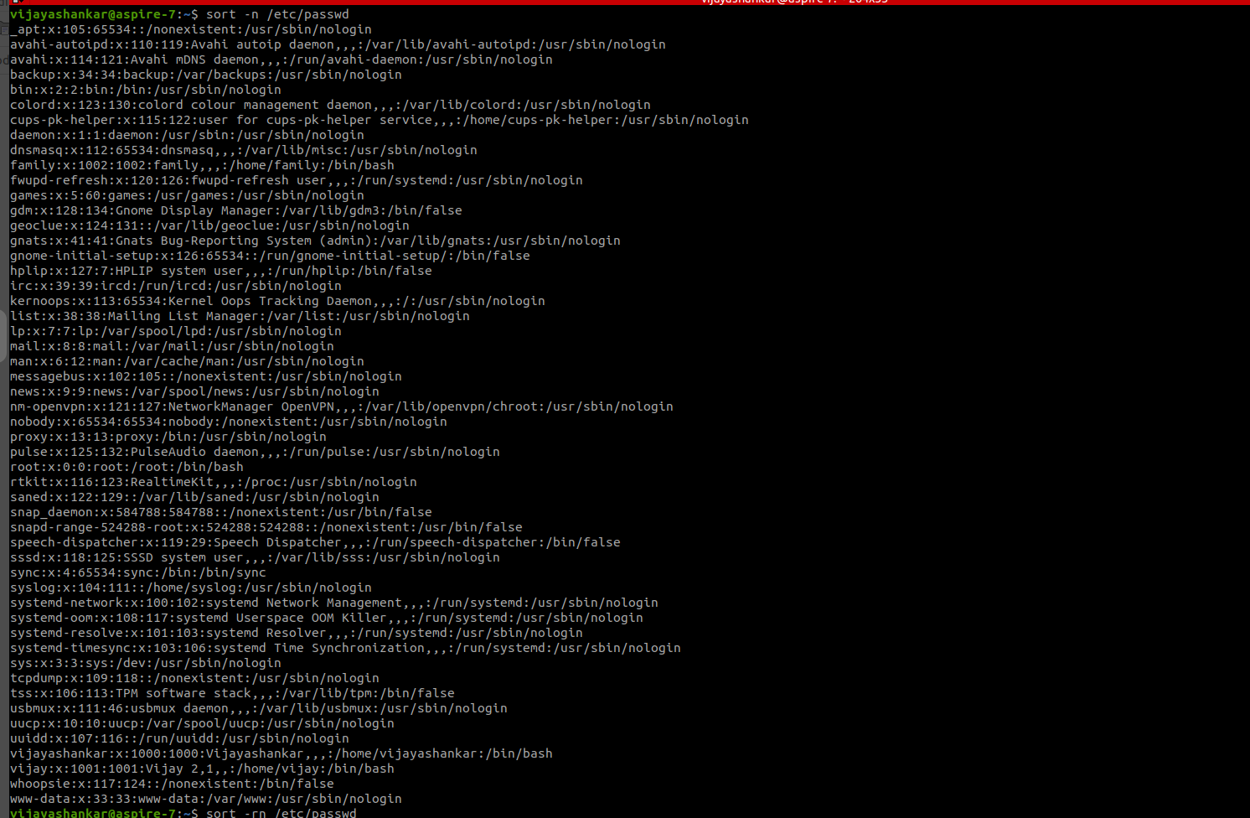
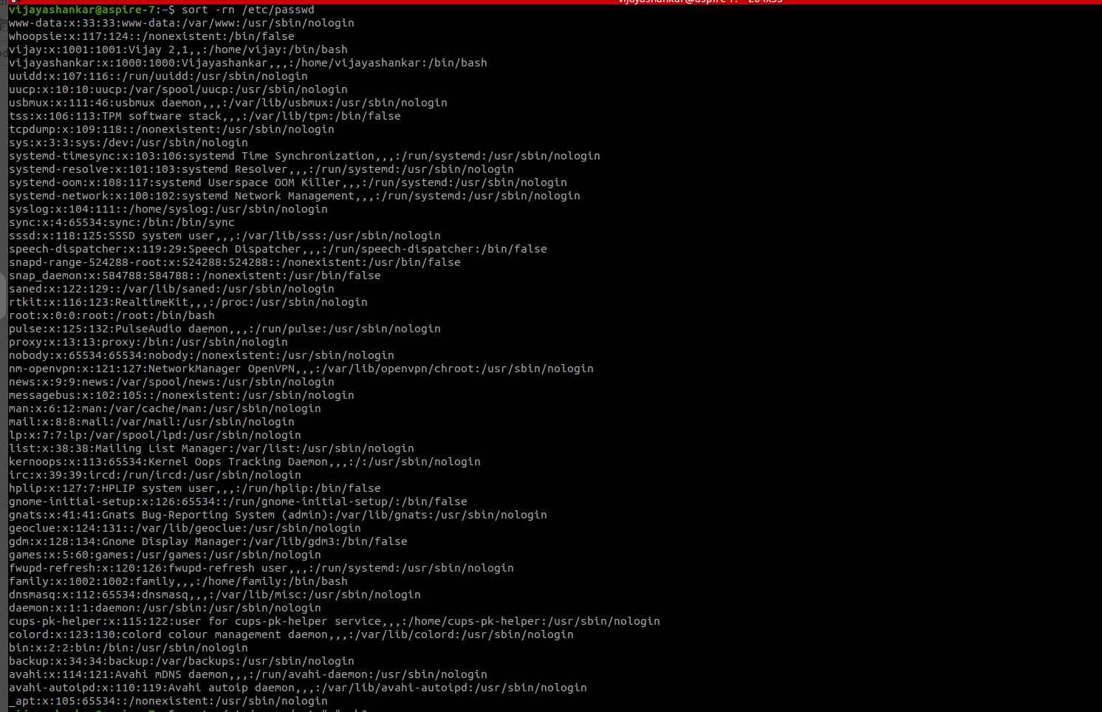
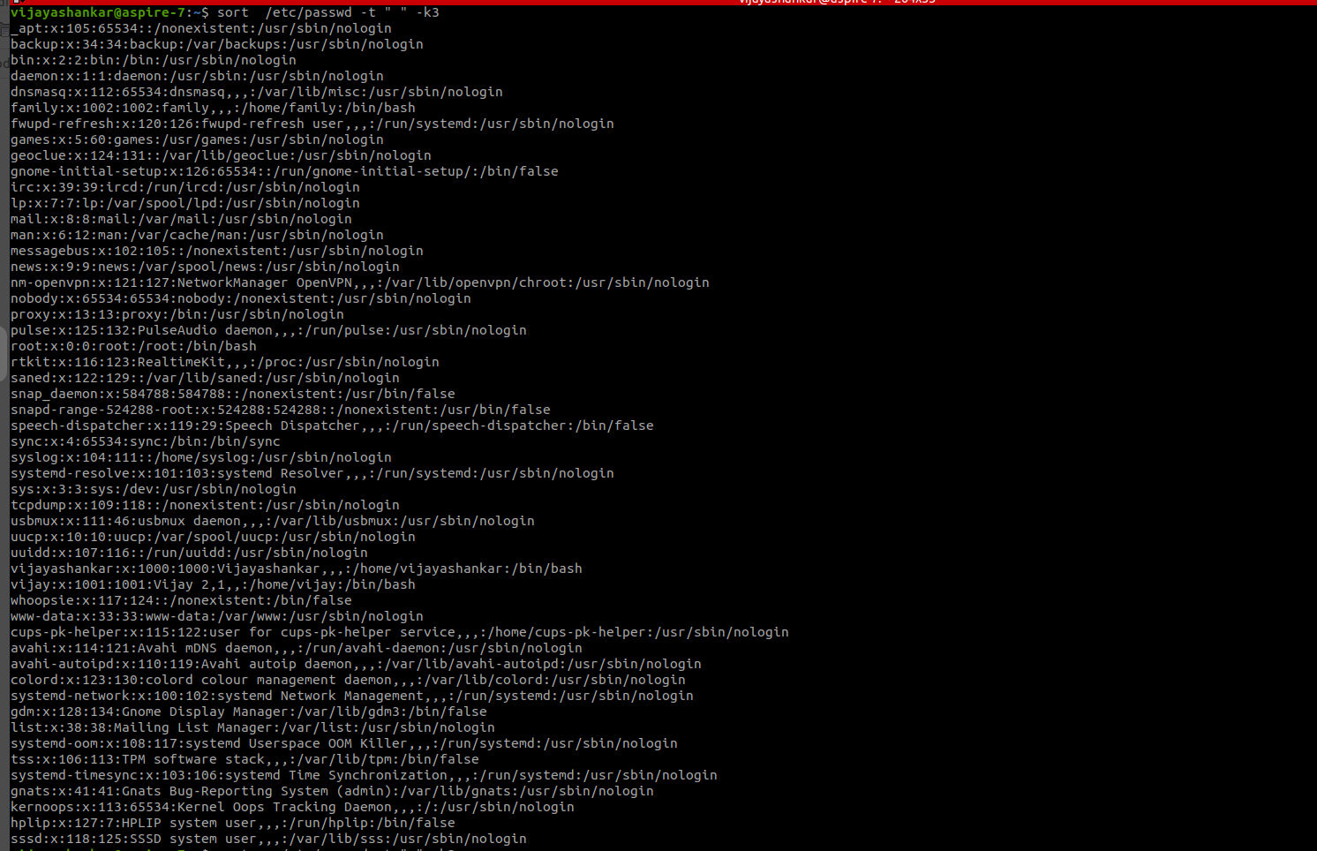
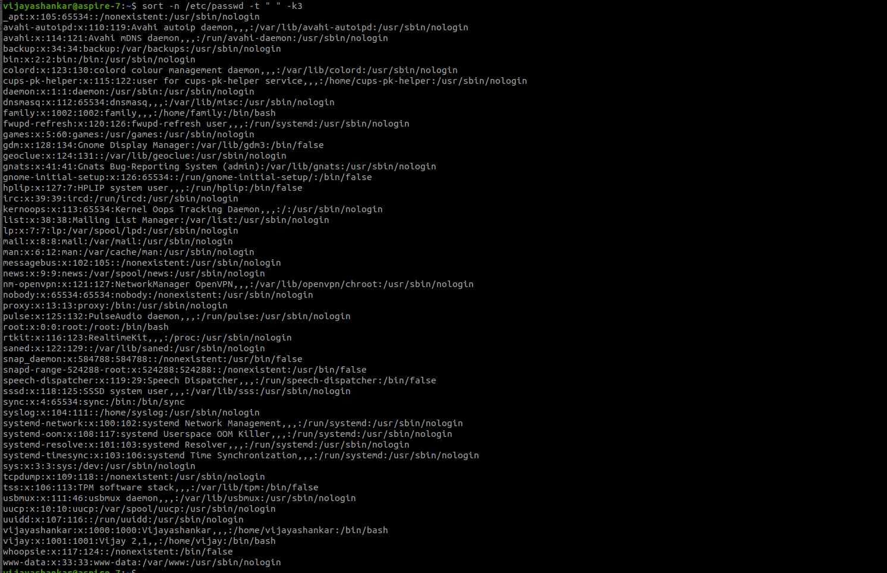
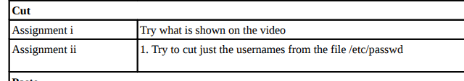

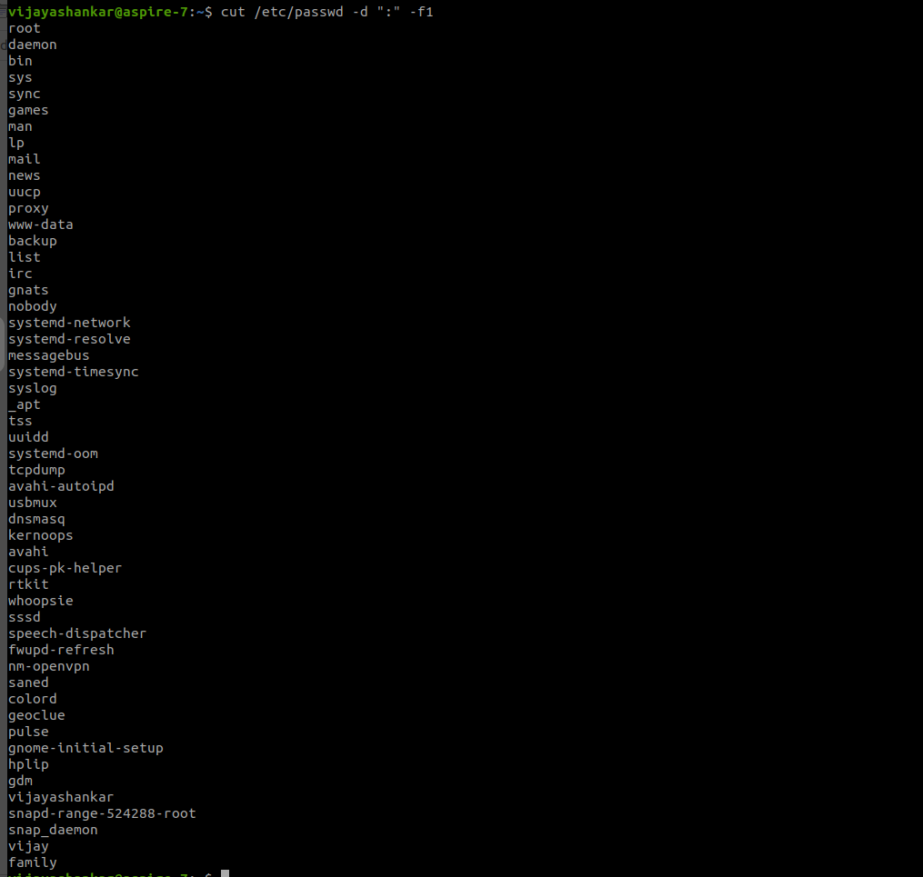
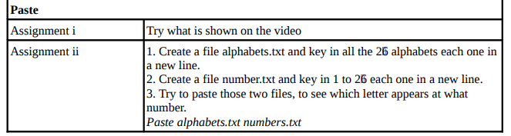
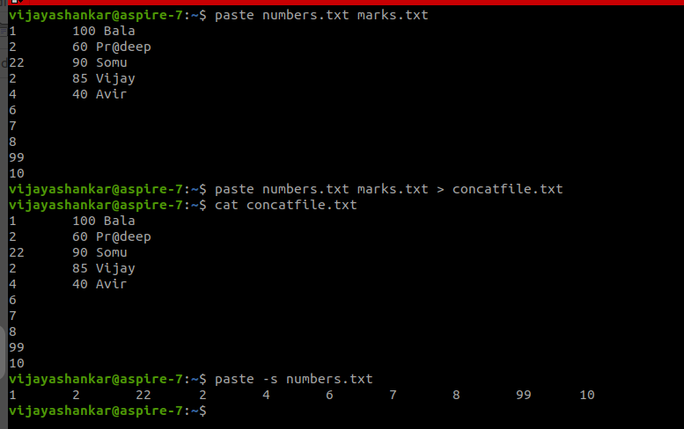
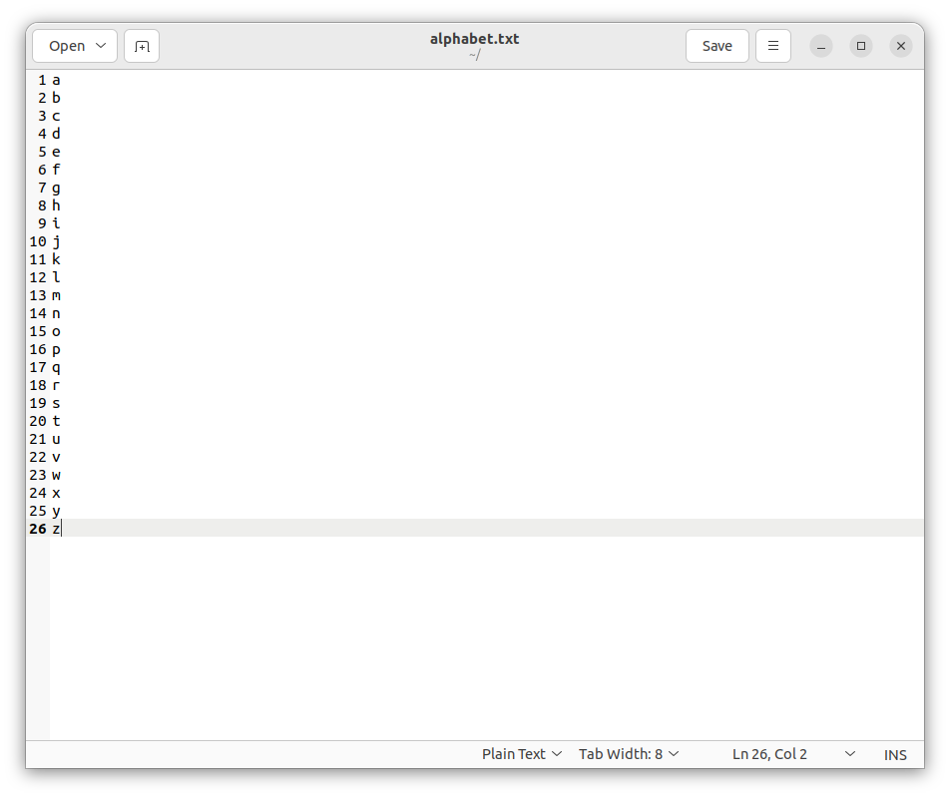

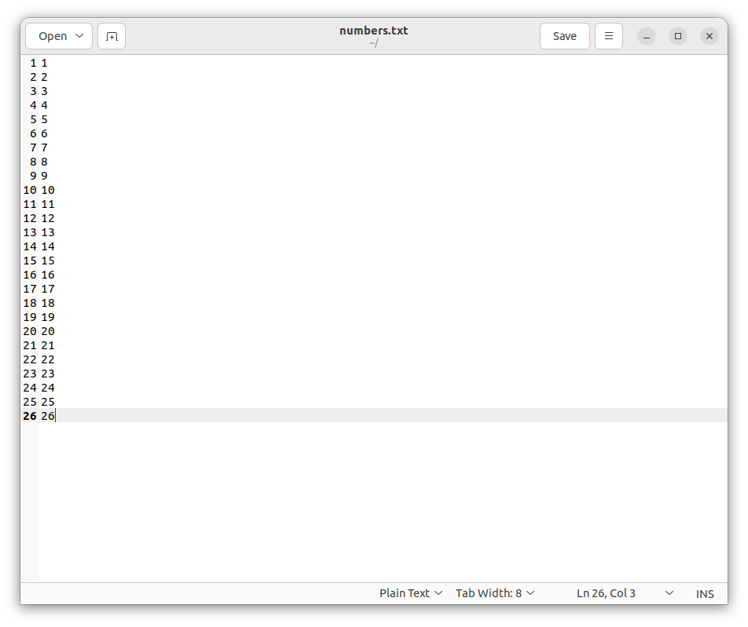

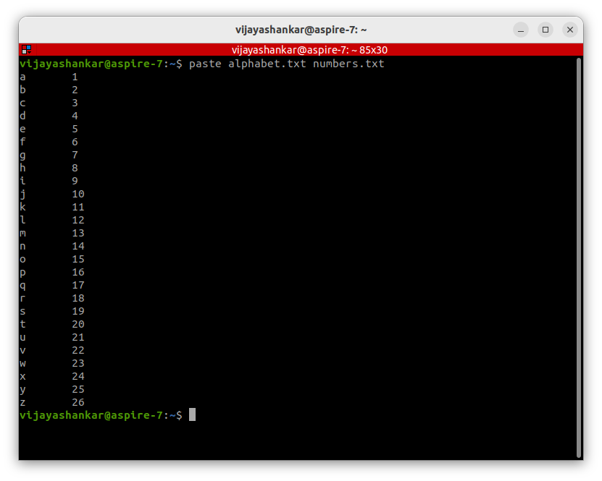

THE GREP COMMAND
1) Explore some other commands like -E, + and ?

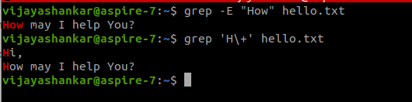
MORE ON GREP CMD
1) List those entries that are 5 letters long and starts with Y

THE SED COMMAND
1) Use the same text file seddemo.txt
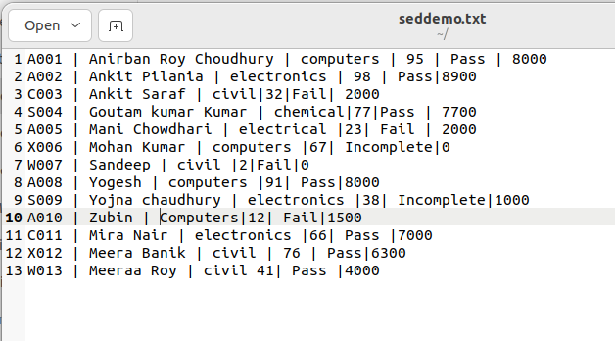

2) Try to print records from 6th to 12th line.

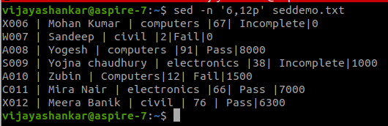

MORE ON SED COMMAND
1) Use the same text file seddemo.txt
2) Try to replace or substitute name Ankit with Ashish
